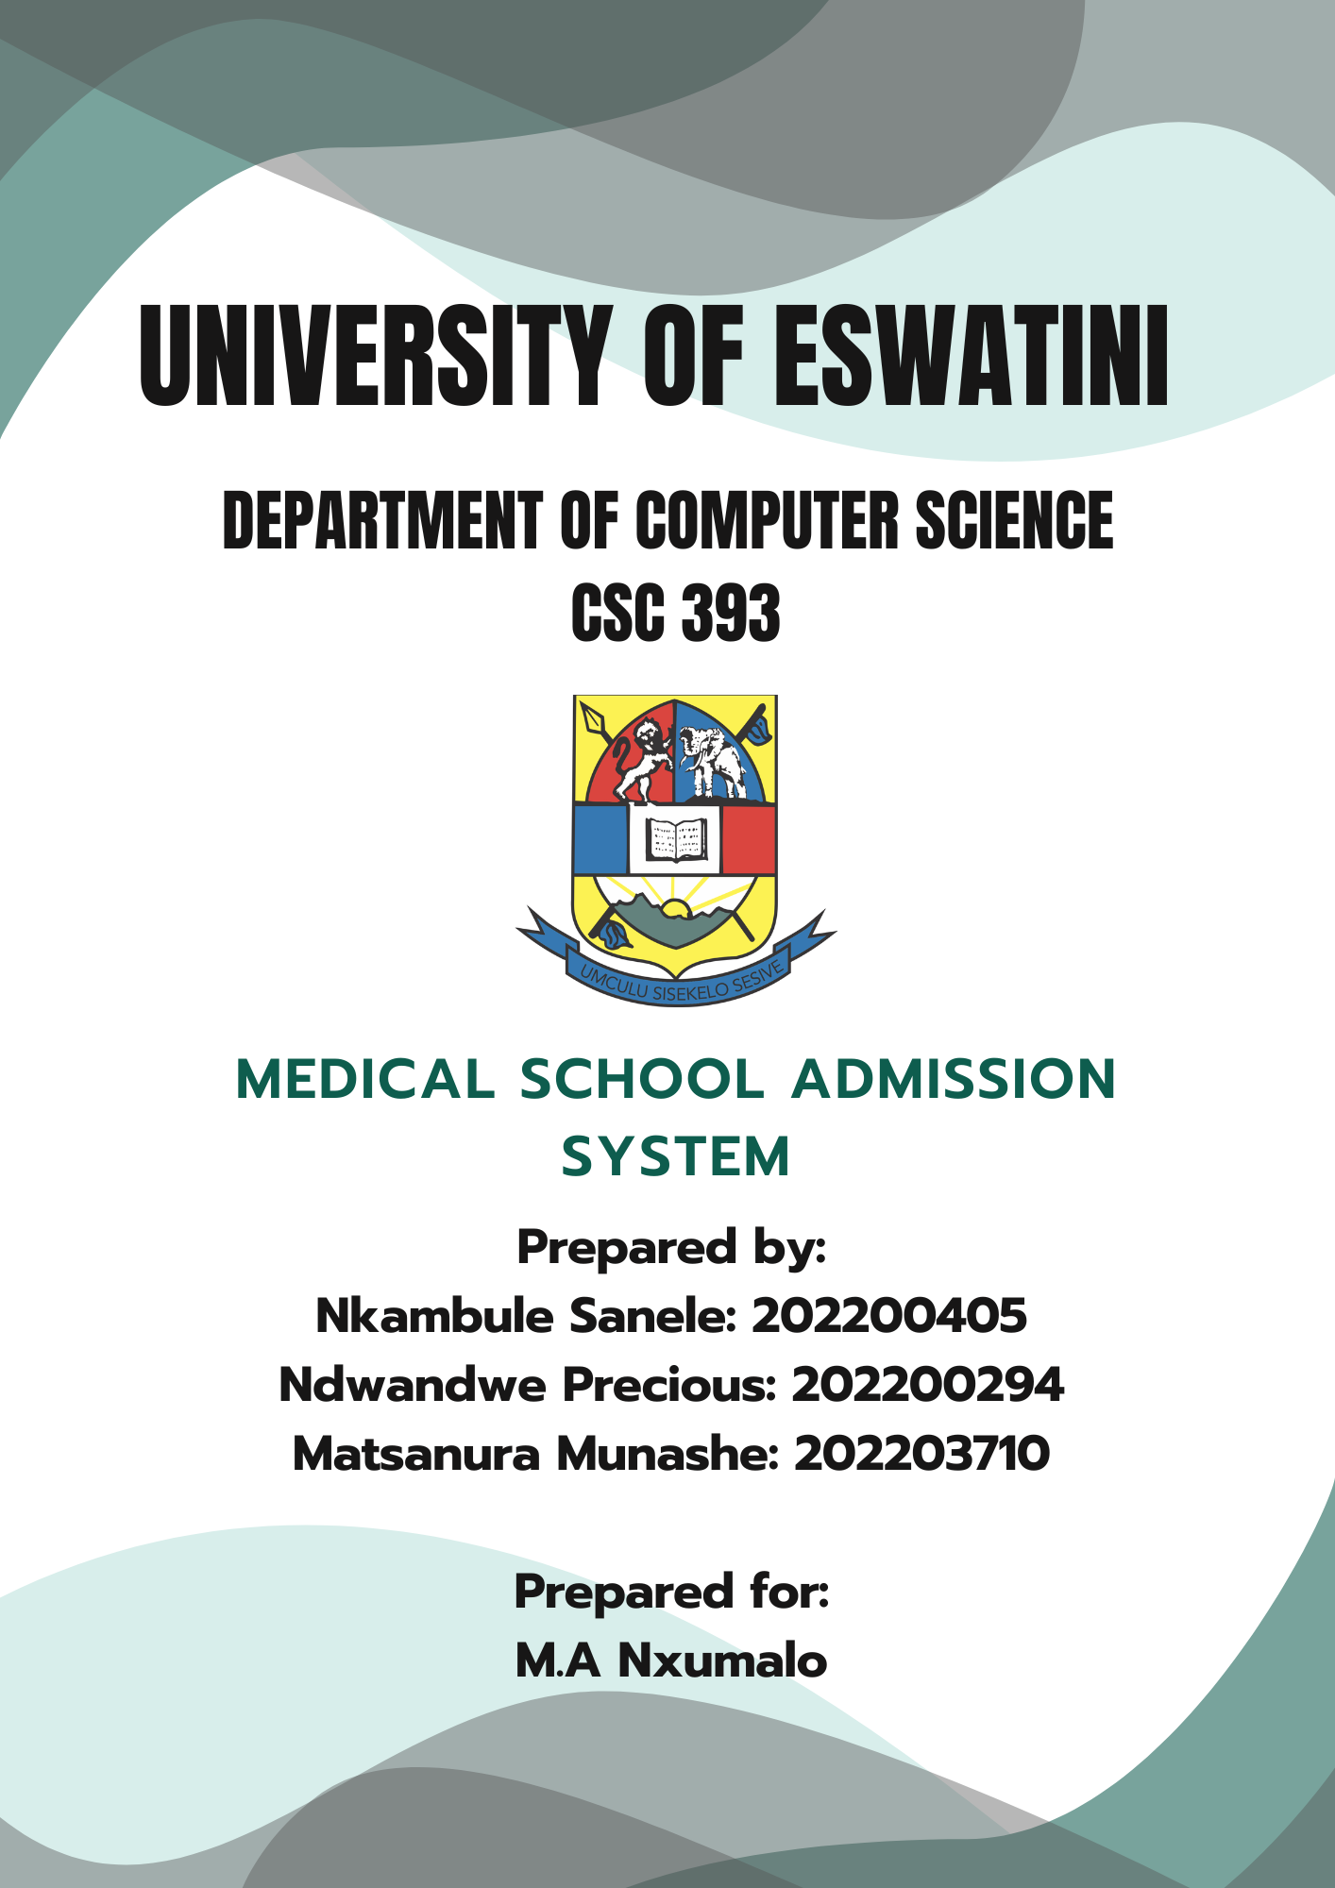

**SECTION A:**

**SOFTWARE SYSTEM PROBLEM IDENTIFICATION**

Medical Admissions System is a process of managing and facilitating the admission of medical students focusing on their grade levels, courses (specifications). The admissions process allows the institution to select students who are good fit for their programs. In this regard, it helps maintain the quality and diversity of student populations, as well as the institutions’ standards. On the other hand, it ensures a fair and transparent process for all applicants while helping students fulfill their educational goals.

An Admission Management System is a specialized piece of software designed to streamline and automate the admission process. It serves as a centralized hub for application tracking, admission task handling. The purpose of the admissions system is to provide support to the administration and admission seeking candidates by providing a faster, transparent, and easy way of maintaining records and utilize them for reference and further proceedings. The online admission system integrates technology with the administrative/education process and is beneficial for both the institution and the students alike. It acts as a new achievement factor in addition to traditional sources of advantages.

The capabilities of an Admission Management System, when successfully implemented, contribute to a more efficient, transparent, and user-friendly admissions process. As a result, educational institutions can streamline various administrative tasks, and applicants can enjoy a more seamless application process. (Morgan, 2024).

**STUDENT ADMISSION PROCESS**

1. The system will provide a personalized interface for applicants, allowing them to create an account and upload documents like personal information, academic transcripts and others related to your essential details.
2. The system will then verify and determines if the documents are eligible to be referred to the admissions committee for review.
3. Payment integration will also be a key feature, enabling applicants to securely submit application fees and receive instant payment confirmations, reducing delays and human errors associated with manual payment processing
4. On the administrative side, the system will allow admissions officers to manage and evaluate applications more efficiently. They will be able to categorize and sort applications based on preset criteria, such as academic performance or geographic location, making it easier to review large volumes of applications.

NB: The system will also facilitate communication between the admissions office and applicants, allowing real-time updates on application status, including interview invitations, missing documents, or final decisions.

1. The interview process will also be managed within the system. Eligible applicants will be notified of available interview dates and can schedule their interviews online. This scheduling feature will automatically send reminders to both applicants and interviewers.
2. Once interviews are completed, the system will support decision-making processes by allowing admissions committees to input their decisions directly into the platform.
3. Applicants will be notified of their acceptance or rejection through both email and the portal. For accepted candidates, the system will provide additional support by guiding them through the enrollment process, including submission of final documents and tuition payments.

The overall design of the system focuses on reducing the administrative hardship on the admissions office, minimizing manual errors, and improving communication between the medical school and it applicants. By providing real-time access to information and updates, the system enhances the user experience for applicants and school administrators, ensuring a more efficient and organized admission process( Laudon, 2020).

**SECTION B:**

**PLANNING**

This Admission Portal System for a Medical School project attempts to address the most serious drawbacks of the poor efficiency of traditional manual paper-based system. The traditional admissions process at many medical schools is extremely paper-driven. Information typically goes back and forth between applicants and their admissions office. Data must be added by hand, which means fewer staff are available for any other work. During all this time-consuming, manually-operated process both applicants and administrators experience delays, errors and frustration. The objective of this project is to introduce a comprehensive digital solution that not only makes all these tasks automatic for administrative staff but also provides applicants with a transparent and convenient process (Allen, et.al, 2011). Reducing the amount of traditional manual processes, which take up manpower and are prone to errors replaced by these now more automated system-wide solutions that not only guarantee the accuracy but also save time allows us to communicate more quickly with our applicants.

The need for such a system stems from the rising number of applicants to medical schools, a trend that makes it difficult for admission offices to efficiently manage the increasing volumes of applications using manual systems. If the institutions admission process contains lots of hassles, a negative impression is created among the students. Students that have been rejected may also not want to try again and sometimes that can be caused by the hassles of the admission process. This shows that the admission process also contributes to the image or reputation of the Institution as whole, stakeholders can have a certain perception based on the admissions process. Furthermore Information leakage issues are also addressed reducing confusion and candidates don't need to stand in long queues to get their queries answered, to get application form, and submit them. Moreover, the need for a centralized and automated system becomes even more critical in the face of the increasingly competitive nature of medical school admissions, where timely decisions and transparent processes can make a considerable difference in attracting the best candidates. Lastly Institutes don't need to assign additional security to manage huge crowds (Abdulazeez et.al, 2018).

As an institution we aim on having an effective system, where all stakeholders are satisfied. This project offers a completely digital platform admission system that is managed entirely via the web. The system allows applicants to create user profiles as well as upload their application materials and pay fees, tracking their progress every step from one mouse click on either very secure or user-friendly platforms. From the administrative perspective, it will automatically verify or refuse applications based upon information received, provide tools to sort and count each type of application according to predesigned rules; offer functions for both scheduling interviews and issuing final admission decisions. In effecting the payment system and interview scheduling such that there is no longer the need for external communications and manual tracking of things, the aim is to simplify further a process that has already been highly rationalized if not outright digitized. The system also serves as a communication tool, through which target groups such as applicants can be informed of shortcomings in their documents, interview schedules and admission results in real time.

There are various groups responsible for the planning and implementation of this project. The immediate stakeholders will be the admissions staff leading to better efficiency, a lighter load in terms of manpower or time served and vice versa better organization. Applicants are another such group, whose concerns over when things will happen and the interval until they are out of date are reduced by this system, which will make clear application processes as ever possible to any concerned parties. In addition, faculty from our medical schools who are involved in candidate interviews and selections will participate in the system to schedule interviews and make final admission decisions. There is still another key stakeholder in IT department, which must support the system, ensure its security and provide technical assistance. Another key stakeholder is the management of the institution as it contributes in decision making, what they decide is crucial for the university. External stakeholders may include payment gateway providers such as those involved in integrating their services into the system for managing application fees (Boninger, et.al, 2010).

The project will bring significant value to these stakeholders by improving the efficiency, transparency, and overall quality of the admissions process. For admissions staff, the system will highly reduce time on repetitive manual activities, allowing them to work on more strategic parts of a candidate selection. For applicants, the portal will serve as a single window to the applicants where they will have a smooth and user-friendly experience to makes applying streamlined and effortless, from document submission to application status updates. Faculty members will benefit from an organized, easy-to-use platform for managing interviews and evaluating candidates, while the IT department will discover use of the process with present day systems making its infrastructure and security features easy to oversee. Ultimately, the system will enhance the reputation of the medical school by demonstrating a commitment to adopting modern, efficient and applicant-friendly admission practices.

Several contextual factors may affect the project’s development and implementation. One major influence will be the existing IT infrastructure of the medical school, which will need to support the new system’s technical requirements, including database integration, user authentication, and security protocols. The system must also contend with the legal and regulatory environment, which is why another key consideration is to stick to the rules and regulations around data privacy, especially as it relates to the processing of personal applicant data. In addition to that, if there are funds to back-up any development and the scope and timeline of the project can be affected by how you will maintain the system after (McLeod, 2011).

Several assumptions have been made in planning this project. Firstly, its assumed that the applicants should have internet access and the level of digital literacy to be able to navigate through the online portal. It is also In this context, we have assumed that the medical school’s existing information technology (IT) infrastructure will support the integration of this new features without too many updates to the system. Also, it's assumed that the budget allocated to this project will pay all the costs of development, implementation, and maintenance.

**SECTION C:**

**REQUIREMENT ANALYSIS**

Gathering accurate and detailed requirements is crucial for creating a comprehensive Software Requirements Specification (SRS) document when developing the Admission Portal System for a medical school into software. Two requirements gathering techniques that can be employed are interviews and questionnaires. Here is how both these techniques are going to be designed:

1. **Interview Design**

Interviews allow for in-depth discussions with different stakeholders to understand their needs, pain points, and expectations regarding the admission system. The goal is to extract functional and non- functional requirements. Basically an interview is a method for collecting information from individuals or a group of people. This can be formal or informal. We aim to conduct both structured and unstructured interview, depending on the individual (Portigal, 2023).

**Interview Audience**:

* ***Enrolled students***: To understand their experience with the admission system and how to improve it.
* ***Admissions officers***: To understand the workflow and challenges in the admissions process and identify essential features like application tracking, user access control, and document management.
* ***IT staff***: :To gather information about system integration, technical constraints, data security and Performance requirements.

**Interview Questions**:

* **For Students**: - Can you walk me through your experience with the medical school admissions process?

- What stood out the most to you?

-What are your thoughts on the current application system?

-What struggles did you face in the application face due to the system in place?

-How can the system be best improved to enhance users’ experience?

* **For Admissions Officers: -** Can you describe your current process for handling student applications?

- What challenges do you face with the current system either manual or digital?

- What key features would make the admission process more efficient for you?

- How do you manage the status of applications (pending, approved, rejected)?

- What level of access control and security do you need when handling sensitivestudent data?

* **For IT staff**: **-** What systems do you currently use that need to integrate with the new portal?

- What data security measures are necessary for handling personal and academic data?

- What technology stack would you recommend for building this portal?

- What is the expected uptime and system performance?

1. **Questionnaire Design**

Questionnaires help gather quantifiable data from a broader audience quickly. This method is ideal for understanding user preferences, challenges and expectations in a structured manner. A questionnaire is basically a research instrument consisting of a series of questions designed to gather information from respondents. It can be used for various purposes (Lund, 2023).

**Questionnaire Audience**:

* ***Enrolled Students***: To understand their needs and preferences when applying.

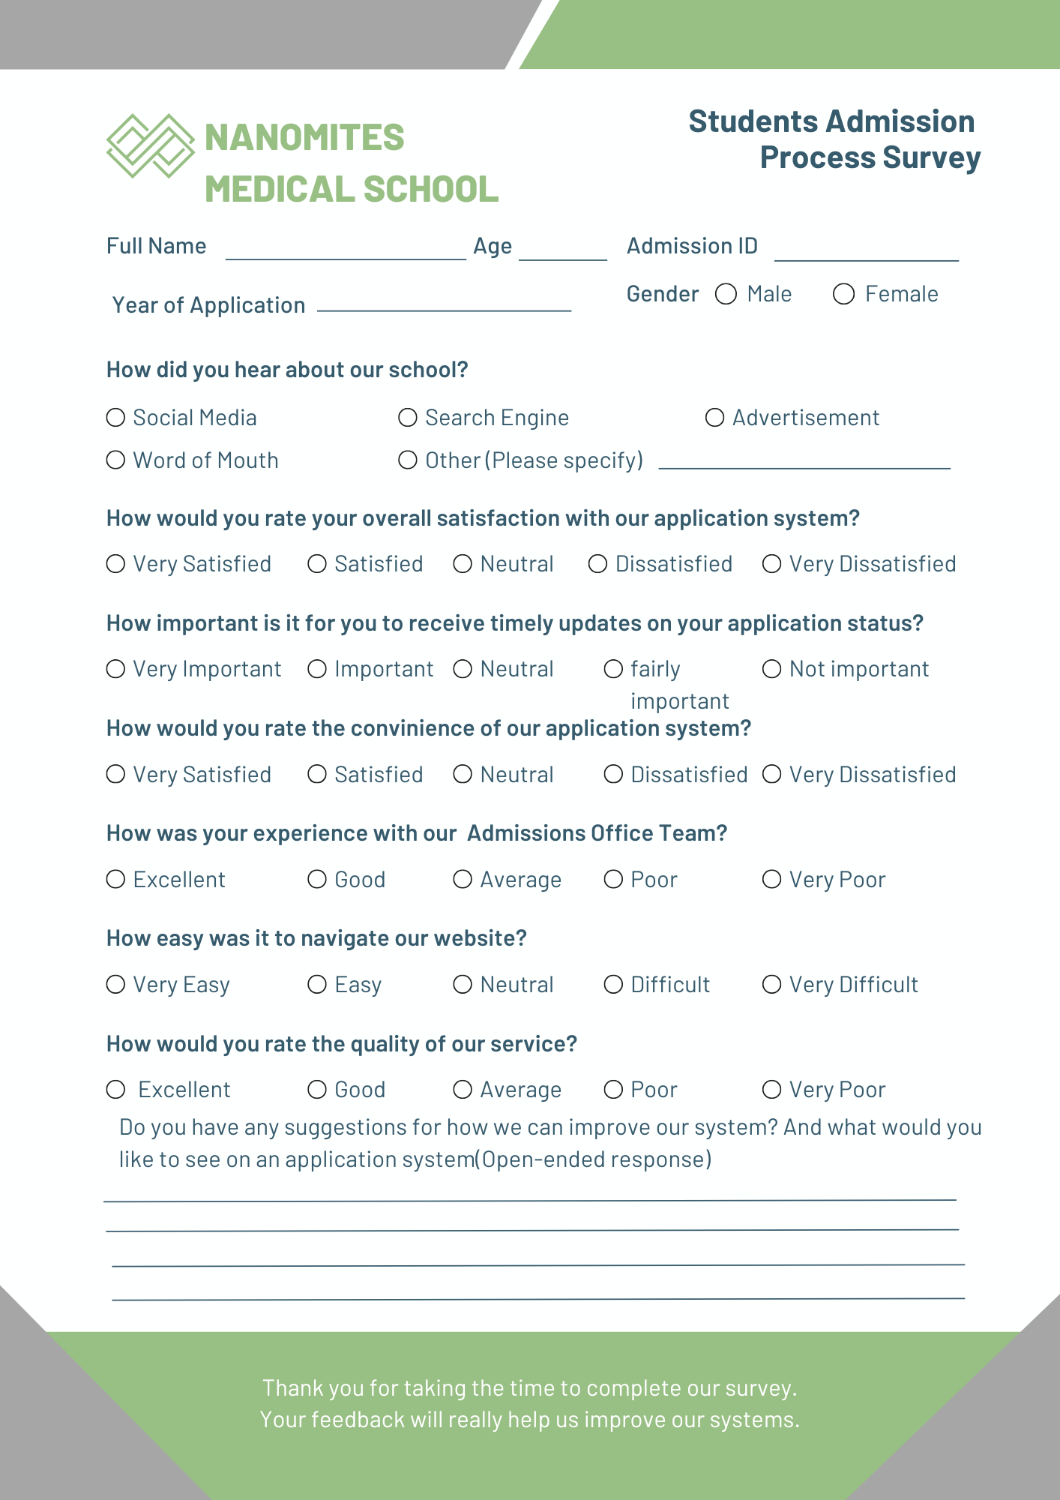

* ***Admissions officers***: To confirm specific needs and challenges in a larger sample.

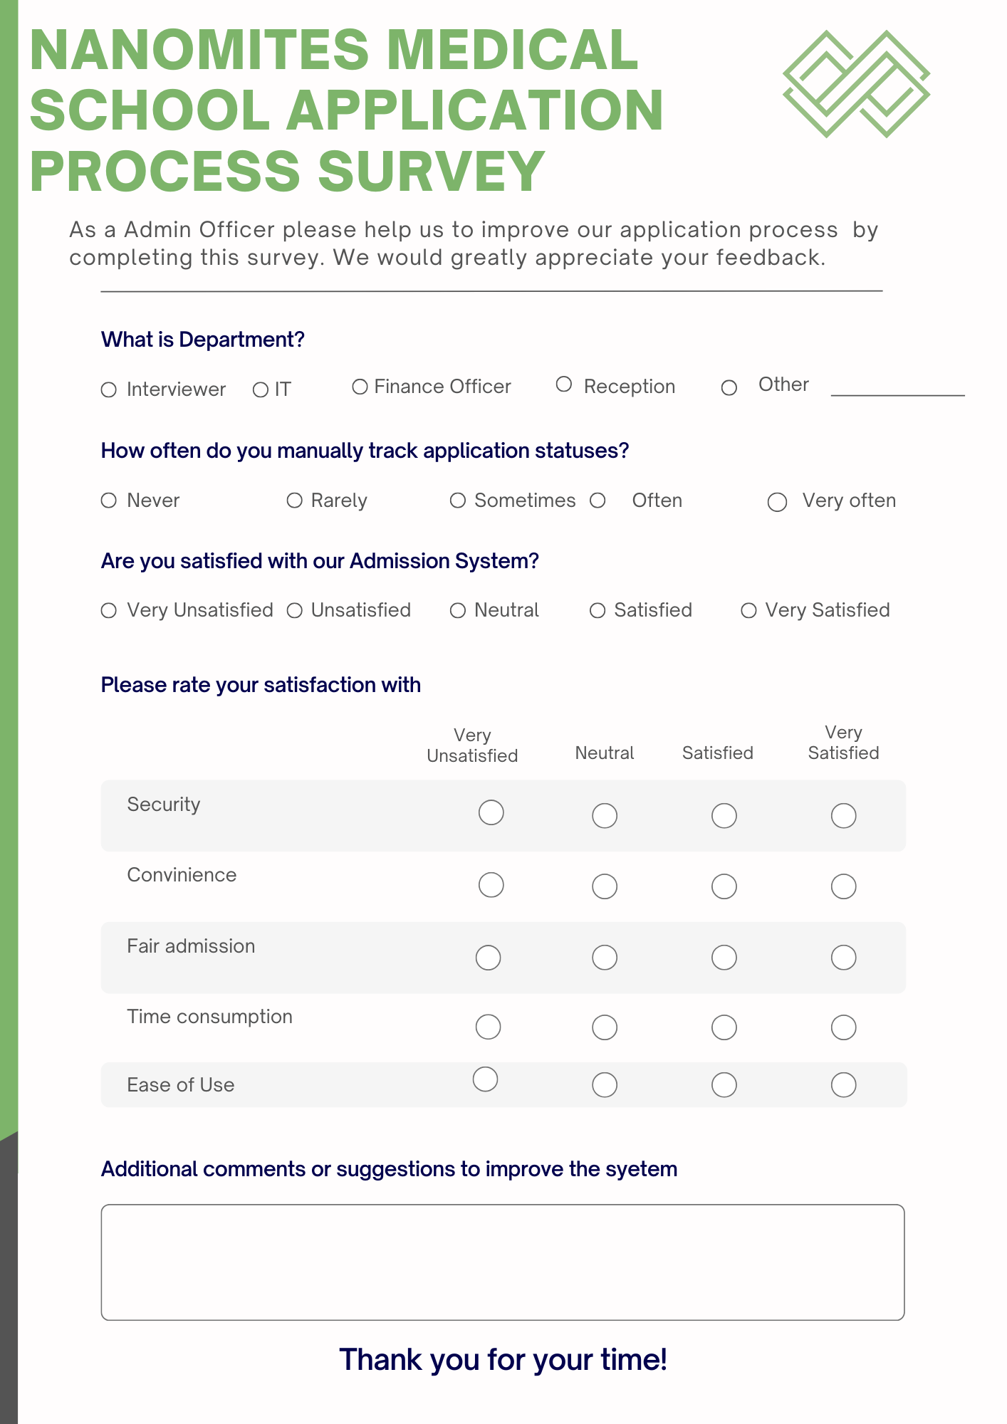

**SECTION D:**

**SYSTEM DESIGN**

1. Level 0 Data Flow Diagram
2. Level 1 Data Flow Diagram
3. Level 2 Data Flow Diagram

**Data Dictionary**

1. **Data Elements:**
2. **Processes:**
3. **Data Stores:**
4. **Data Flows:**
5. **External Entities:**

**SECTION E:**

**GITHUB**

Link to repository: <https://github.com/Moonash16/Admission-Portal-CSC-393.git>

**GitHub Usernames**

Nkambule Sanele - Sanele48

Ndwandwe Precious T- Prechy06

Matsanura Munashe – Moonash16

**REFERENCES**

1. Morgan, A. M. (2024). *Through the Lens of Medical School Admission Deans: Unveiling Perspectives on Medical School Admissions* (Doctoral dissertation, Wilkes University).]
2. Laudon, K., &amp; Laudon, J. (2020). Management Information Systems: Managing the Digital Firm.

Pearson.

1. Abdulazeez, A. M., Zeebaree, S. R., & Sadeeq, M. A. (2018). Design and implementation of electronic student affairs system. *Academic Journal of Nawroz University*, *7*(3), 66-73.
2. Boninger, M., Troen, P., Green, E., Borkan, J., Lance-Jones, C., Humphrey, A., ... & Levine, A. S. (2010). Implementation of a longitudinal mentored scholarly project: an approach at two medical schools. *Academic Medicine*, *85*(3), 429-437.
3. Portigal, S. (2023). *Interviewing users: how to uncover compelling insights*. Rosenfeld Media.
4. Lund, B. (2023). The questionnaire method in systems research: An overview of sample sizes, response rates and statistical approaches utilized in studies. *VINE Journal of Information and Knowledge Management Systems*, *53*(1), 1-10.
5. Allen, P., Billings, L., Cannon, S., Majors, J., Sportsman, S., Ballesteros, P. A., ... & Ross, L. (2011). West Texas nursing education portal project: Developing a regional centralized application system. *Journal of Professional Nursing*, *27*(3), 140-144.
6. McLeod. L , McDonell ,S.G. (2011). Factors that affect software systems development project outcomes: A survey of research. .ACM Jounals *Volume 43, Issue**4October 2011* <https://doi.org/10.1145/1978802.1978803>